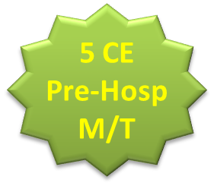


Stress Response to Pediatric Trauma, Christine Campbell, Dir. Trauma Program, LVHN
Substances of Abuse, Kenneth Katz, MD, Emergency Medicine, LVHN
Pediatric Respiratory Emergencies, Zachary Matuzsan, DO, E. M. Resident, LVHN
Pediatric Neuro Emergencies, Victoria Goodheart,DO, E.M. Resident, LVHN
Pediatric Trauma, Briana Tully, DO, E.M. Resident, LVHN
TOPIC TBD, Olubunmi Salako, MD, Pediatric s, LVHN-Poc
**Topics and presenters are subject to change

[Cite your source here.]
Go to www.emiclasses.com and search for “Pediatric Symposium” to register
$15
Registration Fee
Saturday, April 21, 2018
08:30 AM – 1:30 PM ~ Registration Begins at 08:00 AM
Location: LVHN - Cedar Crest, Auditorium
GEM-EMI Presents:
Fourth Annual
Pediatric Symposium

